CE100 Lab Report 1

Getting Familiar

Justin Fortner

Lab 1C

TU/TH 1:30-3:20

10/09/17

**Description:**

The purpose of this lab was to become familiar with the oscilloscope, the BASYS3 Board, Vivado and Verilog. Becoming familiar with these aspects of this class is vital to success in labs going forward. This was accomplished over the course of two parts.

**Part 1-Oscilloscope Methods:**

Part one began by learning how to calibrate the oscilloscope. Once the oscilloscope was properly calibrated the BASYS3 Board was properly attached to the oscilloscope. After properly attaching the BASYS3 Board turn it on and download and configure the provided bit file to the board. Then use the four controls, horizontal sweep rate, vertical gain, trigger level, and holdoff, to display the waveform given by the BASYS3 Board. Lastly, record all values and observations provided by the oscilloscope.

**Part 2-Simple Schematic Methods:**

Part two requires the implementation of 4 circuits. My initial design for each circuit can be seen in the picture below. The lab walks us through how to create, set up, properly code and implement our design. We are also shown how to view our elaborated design of our code. Once the code was properly compiled a bit file was generated and downloaded to the board.

**Part 1-Oscilloscope Results:**

The results gained from this part are given by the oscilloscope when a square wave form is given by each channel. The only calculated result is frequency which is given by 1/Period. The period is given by the the amount of time it takes for the wave to complete one full cycle. A graph of the waveforms can be seen on my lab notebook pages located in the appendix. In the channel 2 square waveform a small glitch appeared in the wave. This is shown in my lab notebook as well.

**Channel 1:**

Horizontal Graduation: Time (μs)

Vertical Graduation: Voltage (V)

Sweep Rate: 5μs/Div

Vertical Gain: 5V/Div

Frequency: 40000Hz

**Channel 2:**

Horizontal Graduation: Time (μs)

Vertical Graduation: Voltage (V)

Sweep Rate: 50μs/Div

Vertical Gain: 2V/Div

Frequency: 10000Hz

**Part 2-Simple Schematic Results:**

There were four different circuits included in this lab. Their respective truth tables can be seen below.

**NOT BTNU:**

Table 1

|  |  |
| --- | --- |
| BTNU | LD0 |
| 0 | 1 |
| 1 | 0 |

As shown in table 1, when the button is pressed the LED is off. When the button is not pressed the LED is on.

**AND BTNL and BTNR:**

Table 2

|  |  |  |
| --- | --- | --- |
| BTNL | BTNR | LD1 |
| 0 | 0 | 0 |
| 0 | 1 | 0 |
| 1 | 0 | 0 |
| 1 | 1 | 1 |

As shown in table 2, the LED only turns on when both button L and button R are pressed.

**OR SW0 and SW1:**

Table 3

|  |  |  |
| --- | --- | --- |
| SW0 | SW1 | LD2 |
| 0 | 0 | 0 |
| 0 | 1 | 1 |
| 1 | 0 | 1 |
| 1 | 1 | 1 |

As shown in table 3, the LED turns on when either switch 1 or switch 2 or both switches are in the on position.

**XOR SW0, SW1 and SW2:**

Table 4

|  |  |  |  |
| --- | --- | --- | --- |
| SW0 | SW1 | SW2 | LD3 |
| 0 | 0 | 0 | 0 |
| 0 | 0 | 1 | 1 |
| 0 | 1 | 0 | 1 |
| 0 | 1 | 1 | 0 |
| 1 | 0 | 0 | 1 |
| 1 | 0 | 1 | 0 |
| 1 | 1 | 0 | 0 |
| 1 | 1 | 1 | 1 |

As shown in table 4, the LED turns on when only one of the switches is in the on position or all three are in the on position.

**Conclusion:**

Both parts of this lab were fairly basic. Their main purpose was to get me familiar with the equipment and software in the lab. I felt this lab did a great job of that. In part 1, I was able to successfully create two square waves with the oscilloscope and correctly record the data that helped me achieve that. In part 2, I correctly implemented the four circuits required by the lab. An interesting observation I made during this lab is that Vivado only uses one or two inputs for the gates. This can be seen in my lab journal pages located in the appendix. Also located in the appendix is my elaborated design and code for part 2 of the lab as well as my lab notebook pages for both part 1 and 2.

**Appendix:**

**Elaborated Design:**

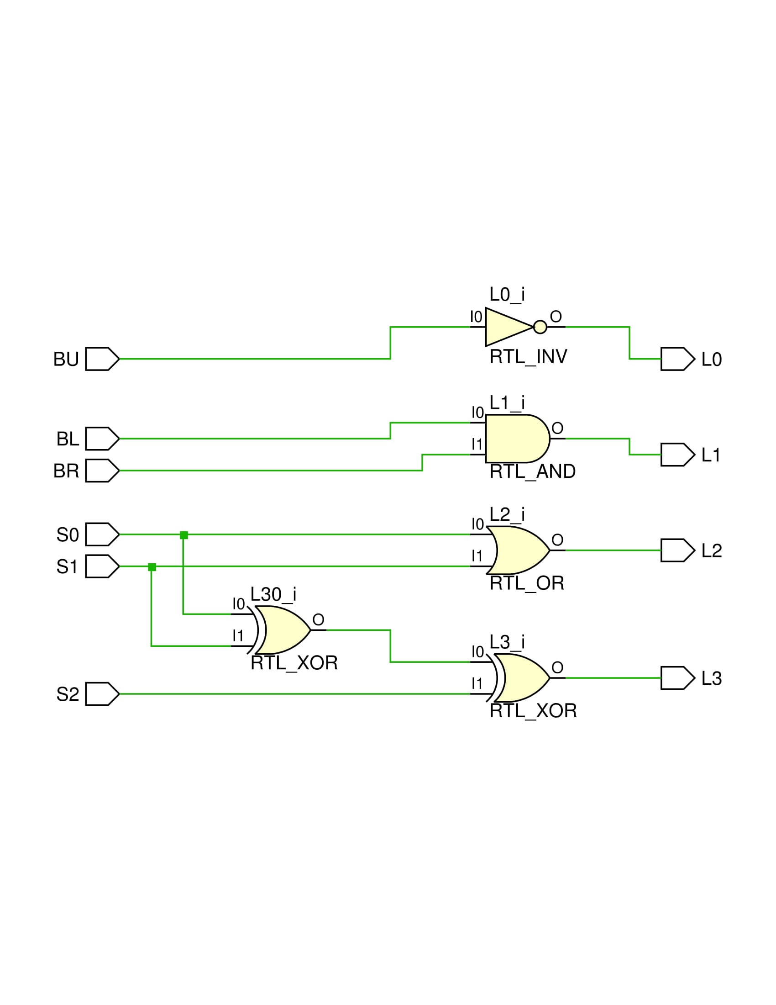

**Verilog Code:**

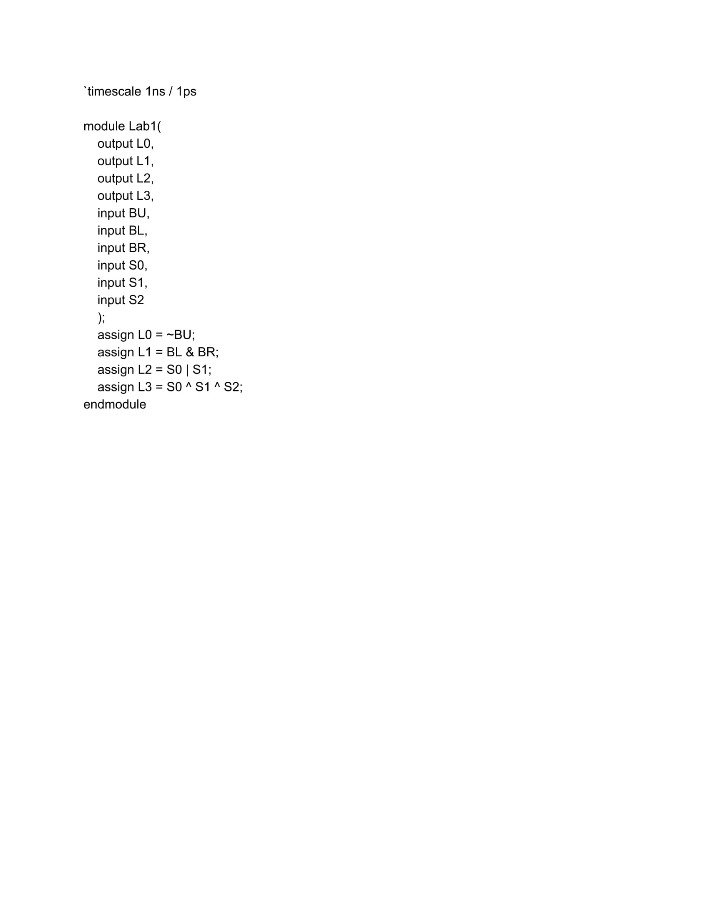

**Scanned Notebook Pages:**

